AIO AI SEO Platform

|  |  |
| --- | --- |
| Relationship | points to AIO AI SEO is a comprehensive, AI-powered platform for personal use in the guiding of content creation (user-part), SEO optimization, and social media management, leveraging free and open-source tools, reverse-engineered APIs, and resources. |
| Relationship | points to  Relying only on free/open‑source software and APIs with free tiers, generous trials, or signup credits. |
| Relationship | begins at dev & technical |
| Relationship | begins at Build |

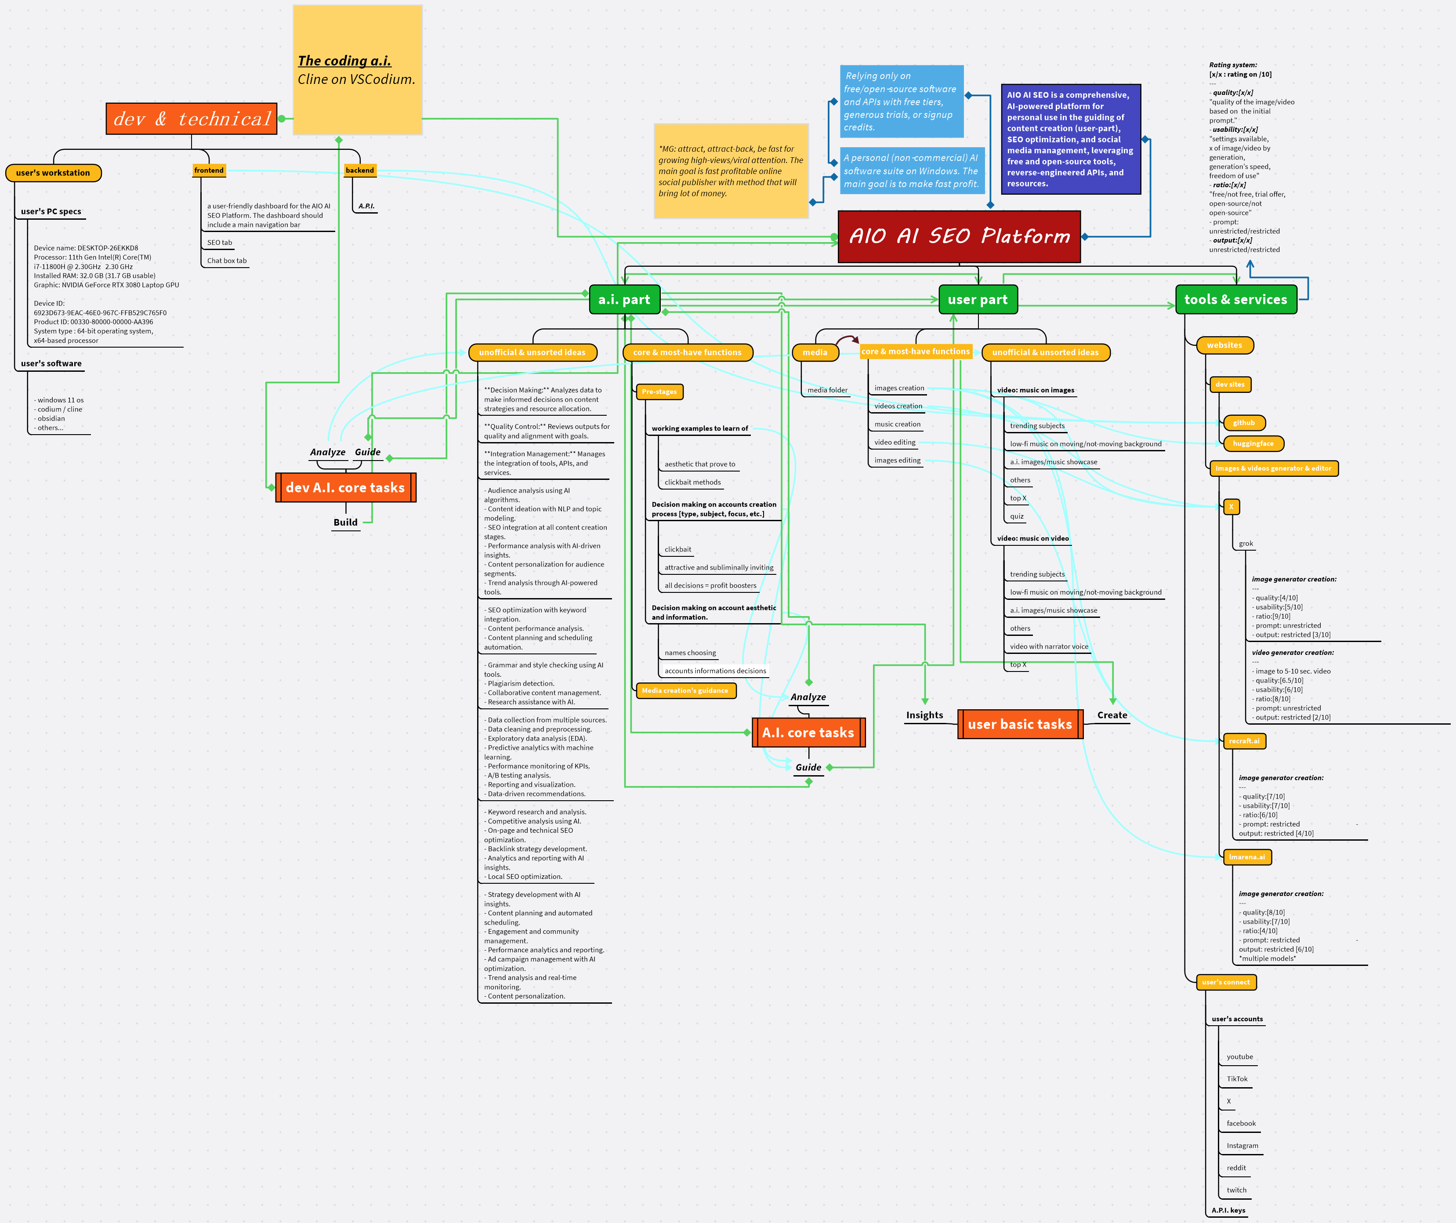

1. a.i. part 5

1.1. **unofficial & unsorted ideas** 5

1.1.1. **Decision Making:** Analyzes data to make informed decisions on content strategies and resource allocation. 5

1.1.2. **Quality Control:** Reviews outputs for quality and alignment with goals. 5

1.1.3. **Integration Management:** Manages the integration of tools, APIs, and services. 5

1.1.4. - Audience analysis using AI algorithms. - Content ideation with NLP and topic modeling. - SEO integration at all content creation stages. - Performance analysis with AI-driven insights. - Content personalization for audience segments. - Trend analysis through AI-powered tools. 5

1.1.5. - SEO optimization with keyword integration. - Content performance analysis. - Content planning and scheduling automation. 5

1.1.6. - Grammar and style checking using AI tools. - Plagiarism detection. - Collaborative content management. - Research assistance with AI. 5

1.1.7. - Data collection from multiple sources. - Data cleaning and preprocessing. - Exploratory data analysis (EDA). - Predictive analytics with machine learning. - Performance monitoring of KPIs. - A/B testing analysis. - Reporting and visualization. - Data-driven recommendations. 5

1.1.8. - Keyword research and analysis. - Competitive analysis using AI. - On-page and technical SEO optimization. - Backlink strategy development. - Analytics and reporting with AI insights. - Local SEO optimization. 5

1.1.9. - Strategy development with AI insights. - Content planning and automated scheduling. - Engagement and community management. - Performance analytics and reporting. - Ad campaign management with AI optimization. - Trend analysis and real-time monitoring. - Content personalization. 5

1.2. **core & most-have functions** 6

1.2.1. **Pre-stages** 6

· **working examples to learn of** 6

· aesthetic that prove to 6

· clickbait methods 6

· **Decision making on accounts creation process [type, subject, focus, etc.]** 6

· clickbait 6

· attractive and subliminally inviting 6

· all decisions = profit boosters 6

· **Decision making on account aesthetic and information.** 6

· names choosing 6

· accounts informations decisions 6

1.2.2. **Media creation's guidance** 6

2. user part 6

2.1. **media** 6

2.1.1. media folder 6

2.2. **core & most-have functions** 7

2.2.1. images creation 7

2.2.2. videos creation 7

2.2.3. music creation 7

2.2.4. video editing 7

2.2.5. images editing 7

2.3. **unofficial & unsorted ideas** 7

2.3.1. **video: music on images** 7

· trending subjects 7

· low-fi music on moving/not-moving background 7

· a.i. images/music showcase 7

· others 7

· top X 7

· quiz 7

2.3.2. **video: music on video** 7

· trending subjects 7

· low-fi music on moving/not-moving background 8

· a.i. images/music showcase 8

· others 8

· video with narrator voice 8

· top X 8

3. tools & services 8

3.1. **websites** 8

3.1.1. **dev sites** 8

· **github** 8

· **huggingface** 8

3.1.2. **Images & videos generator & editor** 8

· **X** 8

· grok 8

· ***image generator creation:*** --- - quality:[4/10] - usability:[5/10] - ratio:[9/10] - prompt: unrestricted - output: restricted [3/10] 9

· ***video generator creation:*** --- - image to 5-10 sec. video - quality:[6.5/10] - usability:[6/10] - ratio:[8/10] - prompt: unrestricted - output: restricted [2/10] 9

· **recraft.ai** 9

· ***image generator creation:*** --- - quality:[7/10] - usability:[7/10] - ratio:[6/10] - prompt: restricted - output: restricted [4/10] 9

· **lmarena.ai** 9

· ***image generator creation:*** --- - quality:[8/10] - usability:[7/10] - ratio:[4/10] - prompt: restricted - output: restricted [6/10] *multiple models* 9

3.2. **user's connect** 9

3.2.1. **user's accounts** 9

· youtube 9

· TikTok 9

· X 9

· facebook 9

· Instagram 9

· reddit 9

· twitch 9

3.2.2. **A.P.I. keys** 9

4. *Relying only on free/open‑source software and APIs with free tiers, generous trials, or signup credits.* 10

5. **AIO AI SEO is a comprehensive, AI-powered platform for personal use in the guiding of content creation (user-part), SEO optimization, and social media management, leveraging free and open-source tools, reverse-engineered APIs, and resources.** 10

6. *A personal (non‑commercial) AI software suite on Windows. The main goal is to make fast profit.* 10

7. ***dev & technical*** 10

7.1. **user's workstation** 10

7.1.1. **user's PC specs** 10

· Device name: DESKTOP-26EKKD8 Processor: 11th Gen Intel(R) Core(TM) i7-11800H @ 2.30GHz 2.30 GHz Installed RAM: 32.0 GB (31.7 GB usable) Graphic: NVIDIA GeForce RTX 3080 Laptop GPU Device ID: 6923D673-9EAC-46E0-967C-FFB529C765F0 Product ID: 00330-80000-00000-AA396 System type : 64-bit operating system, x64-based processor 10

7.1.2. **user's software** 10

· - windows 11 os - codium / cline - obsidian - others... 10

7.2. **frontend** 10

7.2.1. a user-friendly dashboard for the AIO AI SEO Platform. The dashboard should include a main navigation bar 11

7.2.2. SEO tab 11

7.2.3. Chat box tab 11

7.3. **backend** 11

7.3.1. ***A.P.I.*** 11

8. *\*MG: attract, attract-back, be fast for growing high-views/viral attention. The main goal is fast profitable online social publisher with method that will bring lot of money.* 11

9. ***Rating system:* [x/x : rating on /10]** --- - ***quality:[x/x]*** "quality of the image/video based on the initial prompt." - ***usability:[x/x]*** "settings available, x of image/video by generation, generation's speed, freedom of use" - ***ratio:[x/x]*** "free/not free, trial offer, open-source/not open-source" - prompt: unrestricted/restricted - ***output:[x/x]*** unrestricted/restricted 11

10. **dev A.I. core tasks** 11

10.1. ***Analyze*** 11

10.2. ***Guide*** 11

10.3. **Build** 12

11. **user basic tasks** 12

11.1. **Create** 12

11.2. **Insights** 12

12. **A.I. core tasks** 12

12.1. ***Analyze*** 12

12.2. ***Guide*** 12

13. ***The coding a.i.*** *Cline on VSCodium.* 12

1. a.i. part

|  |  |
| --- | --- |
| Relationship | points to tools & services |
| Relationship | points to user part |
| Relationship | begins at A.I. core tasks |
| Relationship | begins at Analyze |
| Relationship | begins at Guide |
| Relationship | begins at Guide |
| Relationship | points to Insights |

* 1. **unofficial & unsorted ideas**

|  |  |
| --- | --- |
| Relationship | begins at Analyze |

* + 1. **Decision Making:** Analyzes data to make informed decisions on content strategies and resource allocation.
    2. **Quality Control:** Reviews outputs for quality and alignment with goals.
    3. **Integration Management:** Manages the integration of tools, APIs, and services.
    4. - Audience analysis using AI algorithms. - Content ideation with NLP and topic modeling. - SEO integration at all content creation stages. - Performance analysis with AI-driven insights. - Content personalization for audience segments. - Trend analysis through AI-powered tools.
    5. - SEO optimization with keyword integration. - Content performance analysis. - Content planning and scheduling automation.
    6. - Grammar and style checking using AI tools. - Plagiarism detection. - Collaborative content management. - Research assistance with AI.
    7. - Data collection from multiple sources. - Data cleaning and preprocessing. - Exploratory data analysis (EDA). - Predictive analytics with machine learning. - Performance monitoring of KPIs. - A/B testing analysis. - Reporting and visualization. - Data-driven recommendations.
    8. - Keyword research and analysis. - Competitive analysis using AI. - On-page and technical SEO optimization. - Backlink strategy development. - Analytics and reporting with AI insights. - Local SEO optimization.
    9. - Strategy development with AI insights. - Content planning and automated scheduling. - Engagement and community management. - Performance analytics and reporting. - Ad campaign management with AI optimization. - Trend analysis and real-time monitoring. - Content personalization.
  1. **core & most-have functions**
     1. **Pre-stages**
        + **working examples to learn of**

|  |  |
| --- | --- |
| Relationship | points to Analyze |

* + - * + aesthetic that prove to
        + clickbait methods
      * **Decision making on accounts creation process [type, subject, focus, etc.]**

|  |  |
| --- | --- |
| Relationship | points to Guide |

* + - * + clickbait
        + attractive and subliminally inviting
        + all decisions = profit boosters
      * **Decision making on account aesthetic and information.**

|  |  |
| --- | --- |
| Relationship | points to Guide |

* + - * + names choosing
        + accounts informations decisions
    1. **Media creation's guidance**

1. user part

|  |  |
| --- | --- |
| Relationship | points to tools & services |
| Relationship | begins at a.i. part |
| Relationship | begins at Guide |
| Relationship | begins at Guide |

* 1. **media**

|  |  |
| --- | --- |
| Relationship | points to core & most-have functions |

* + 1. media folder
  1. **core & most-have functions**

|  |  |
| --- | --- |
| Relationship | begins at media |
| Relationship | points to Create |

* + 1. images creation

|  |  |
| --- | --- |
| Relationship | points to X |
| Relationship | points to huggingface |
| Relationship | points to recraft.ai |
| Relationship | points to lmarena.ai |

* + 1. videos creation

|  |  |
| --- | --- |
| Relationship | points to X |

* + 1. music creation
    2. video editing

|  |  |
| --- | --- |
| Relationship | points to X |

* + 1. images editing

|  |  |
| --- | --- |
| Relationship | points to recraft.ai |

* 1. **unofficial & unsorted ideas**

|  |  |
| --- | --- |
| Relationship | begins at Analyze |

* + 1. **video: music on images**
       - trending subjects
       - low-fi music on moving/not-moving background
       - a.i. images/music showcase
       - others
       - top X
       - quiz
    2. **video: music on video**
       - trending subjects
       - low-fi music on moving/not-moving background
       - a.i. images/music showcase
       - others
       - video with narrator voice
       - top X

1. tools & services

|  |  |
| --- | --- |
| Relationship | begins at user part |
| Relationship | points to Rating system: [x/x : rating on /10] --- - quality:[x/x] "quality of the image/video based on the initial prompt." - usability:[x/x] "settings available, x of image/video by generation, generation's speed, freedom of use" - ratio:[x/x] "free/not free, trial offer, open-source/not open-source" - prompt: unrestricted/restricted - output:[x/x] unrestricted/restricted |
| Relationship | begins at a.i. part |

* 1. **websites**
     1. **dev sites**
        + **github**

|  |  |
| --- | --- |
| Relationship | begins at frontend |
| Relationship | begins at backend |

* + - * **huggingface**

|  |  |
| --- | --- |
| Relationship | begins at images creation |

* + 1. **Images & videos generator & editor**
       - **X**

|  |  |
| --- | --- |
| Relationship | begins at images creation |
| Relationship | begins at videos creation |
| Relationship | begins at video editing |

* + - * + grok

***image generator creation:*** --- - quality:[4/10] - usability:[5/10] - ratio:[9/10] - prompt: unrestricted - output: restricted [3/10]

***video generator creation:*** --- - image to 5-10 sec. video - quality:[6.5/10] - usability:[6/10] - ratio:[8/10] - prompt: unrestricted - output: restricted [2/10]

* + - * **recraft.ai**

|  |  |
| --- | --- |
| Relationship | begins at images editing |
| Relationship | begins at images creation |

* + - * + ***image generator creation:*** --- - quality:[7/10] - usability:[7/10] - ratio:[6/10] - prompt: restricted - output: restricted [4/10]
      * **lmarena.ai**

|  |  |
| --- | --- |
| Relationship | begins at images creation |

* + - * + ***image generator creation:*** --- - quality:[8/10] - usability:[7/10] - ratio:[4/10] - prompt: restricted - output: restricted [6/10] *multiple models*
  1. **user's connect**
     1. **user's accounts**
        + youtube
        + TikTok
        + X
        + facebook
        + Instagram
        + reddit
        + twitch
     2. **A.P.I. keys**

1. *Relying only on free/open‑source software and APIs with free tiers, generous trials, or signup credits.*

|  |  |
| --- | --- |
| Relationship | points to A personal (non‑commercial) AI software suite on Windows. The main goal is to make fast profit. |
| Relationship | begins at AIO AI SEO Platform |

1. **AIO AI SEO is a comprehensive, AI-powered platform for personal use in the guiding of content creation (user-part), SEO optimization, and social media management, leveraging free and open-source tools, reverse-engineered APIs, and resources.**

|  |  |
| --- | --- |
| Relationship | begins at AIO AI SEO Platform |

1. *A personal (non‑commercial) AI software suite on Windows. The main goal is to make fast profit.*

|  |  |
| --- | --- |
| Relationship | begins at  Relying only on free/open‑source software and APIs with free tiers, generous trials, or signup credits. |
| Relationship | begins at *MG: attract, attract-back, be fast for growing high-views/viral attention. The main goal is fast profitable online social publisher with method that will bring lot of money. |

1. ***dev & technical***

|  |  |
| --- | --- |
| Relationship | points to AIO AI SEO Platform |

* 1. **user's workstation**
     1. **user's PC specs**
        + Device name: DESKTOP-26EKKD8 Processor: 11th Gen Intel(R) Core(TM) i7-11800H @ 2.30GHz 2.30 GHz Installed RAM: 32.0 GB (31.7 GB usable) Graphic: NVIDIA GeForce RTX 3080 Laptop GPU Device ID: 6923D673-9EAC-46E0-967C-FFB529C765F0 Product ID: 00330-80000-00000-AA396 System type : 64-bit operating system, x64-based processor
     2. **user's software**
        + - windows 11 os - codium / cline - obsidian - others...
  2. **frontend**

|  |  |
| --- | --- |
| Relationship | points to github |

* + 1. a user-friendly dashboard for the AIO AI SEO Platform. The dashboard should include a main navigation bar
    2. SEO tab
    3. Chat box tab
  1. **backend**

|  |  |
| --- | --- |
| Relationship | points to github |

* + 1. ***A.P.I.***

1. *\*MG: attract, attract-back, be fast for growing high-views/viral attention. The main goal is fast profitable online social publisher with method that will bring lot of money.*

|  |  |
| --- | --- |
| Relationship | points to A personal (non‑commercial) AI software suite on Windows. The main goal is to make fast profit. |

1. ***Rating system:* [x/x : rating on /10]** --- - ***quality:[x/x]*** "quality of the image/video based on the initial prompt." - ***usability:[x/x]*** "settings available, x of image/video by generation, generation's speed, freedom of use" - ***ratio:[x/x]*** "free/not free, trial offer, open-source/not open-source" - prompt: unrestricted/restricted - ***output:[x/x]*** unrestricted/restricted

|  |  |
| --- | --- |
| Relationship | begins at tools & services |

1. **dev A.I. core tasks**

|  |  |
| --- | --- |
| Relationship | points to The coding a.i. Cline on VSCodium. |

* 1. ***Analyze***

|  |  |
| --- | --- |
| Relationship | points to unofficial & unsorted ideas |
| Relationship | points to unofficial & unsorted ideas |

* 1. ***Guide***

|  |  |
| --- | --- |
| Relationship | points to a.i. part |
| Relationship | points to user part |

* 1. **Build**

|  |  |
| --- | --- |
| Relationship | points to AIO AI SEO Platform |

1. **user basic tasks**
   1. **Create**

|  |  |
| --- | --- |
| Relationship | begins at core & most-have functions |

* 1. **Insights**

|  |  |
| --- | --- |
| Relationship | begins at a.i. part |

1. **A.I. core tasks**

|  |  |
| --- | --- |
| Relationship | points to a.i. part |

* 1. ***Analyze***

|  |  |
| --- | --- |
| Relationship | begins at working examples to learn of |
| Relationship | points to a.i. part |

* 1. ***Guide***

|  |  |
| --- | --- |
| Relationship | begins at Decision making on accounts creation process [type, subject, focus, etc.] |
| Relationship | begins at Decision making on account aesthetic and information. |
| Relationship | points to a.i. part |
| Relationship | points to user part |

1. ***The coding a.i.*** *Cline on VSCodium.*

|  |  |
| --- | --- |
| Relationship | begins at dev A.I. core tasks |